**Poweshell**:

PowerShell is a cross-platform task automation solution made up of a command-line shell, a scripting language, and a configuration management framework. PowerShell runs on Windows, Linux, and macOS.

**Shell**

PowerShell is a modern command shell that includes the best features of other popular shells. Unlike most shells that only accept and return text, PowerShell accepts and returns .NET objects. The shell includes the following features:

**Scripting language**

As a scripting language, PowerShell is commonly used for automating the management of systems. It is also used to build, test, and deploy solutions, often in CI/CD environments. PowerShell is built on the .NET Common Language Runtime (CLR). All inputs and outputs are .NET objects.

**Poweshell:**

Open windows powershell in pc with powershell with ISE and perform following commands

1)to create directory New-Item -Path ‘c:\file\foldername’ -ItemType Directory

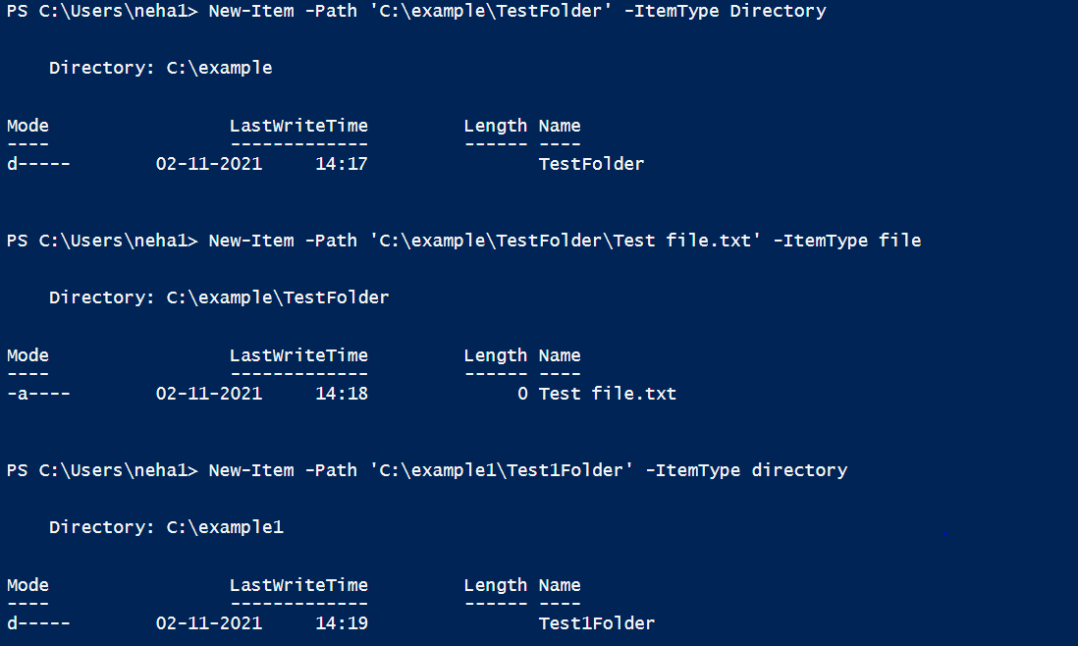

2)To create file in directory New-Item -Path ‘c:\file\foldername\filename’ -ItemType File

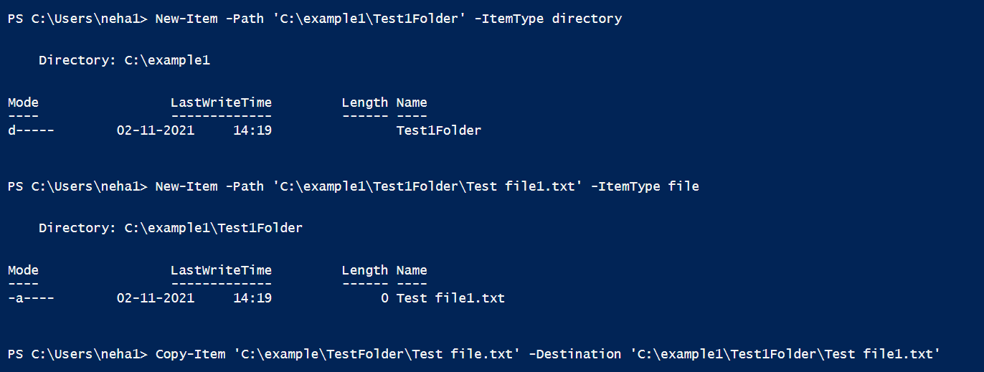

3)add content and get content and set contentusing following command

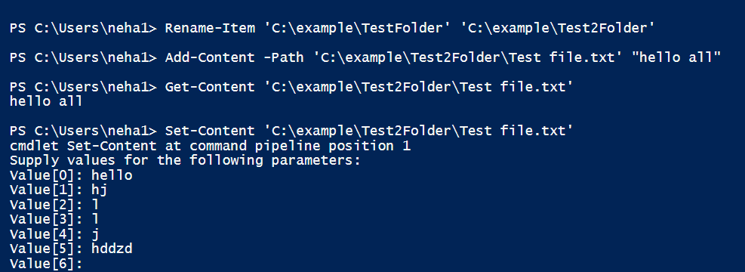

4)To find out length of file use .length

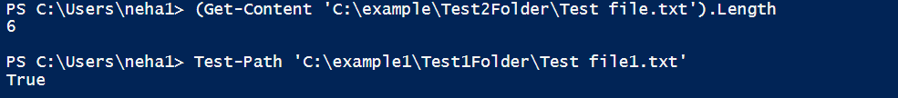

5)get-date

Get date without time or date

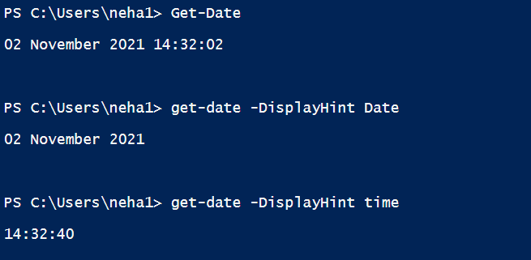

6)make list and sort it and get unique list

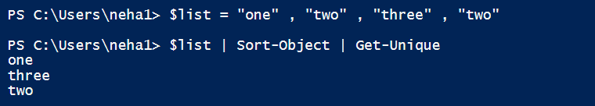

7)compare

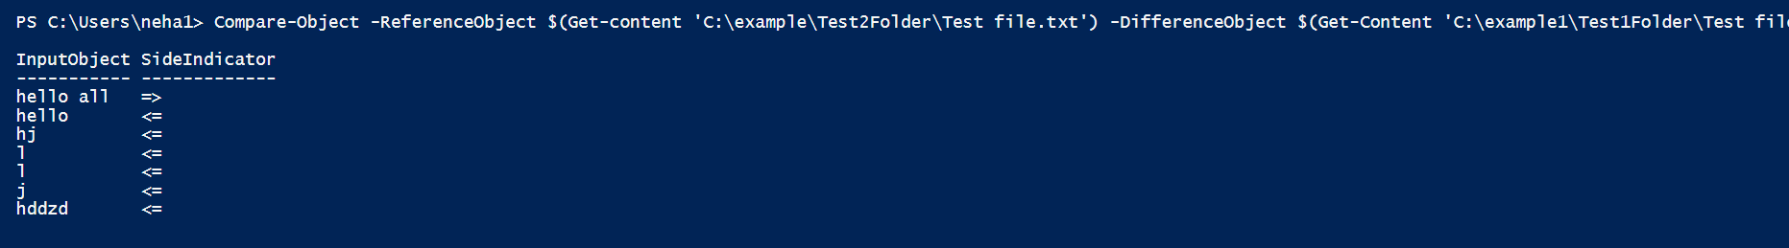

8)

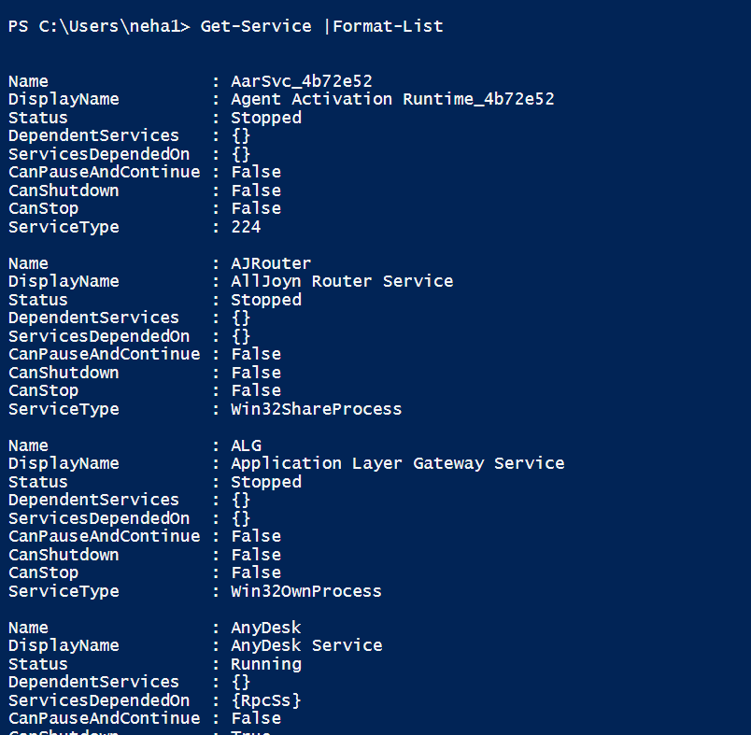

9)for warning:



10)to see location

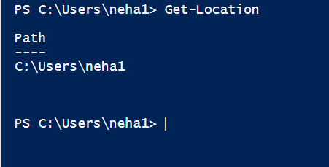

11)we can find child item

